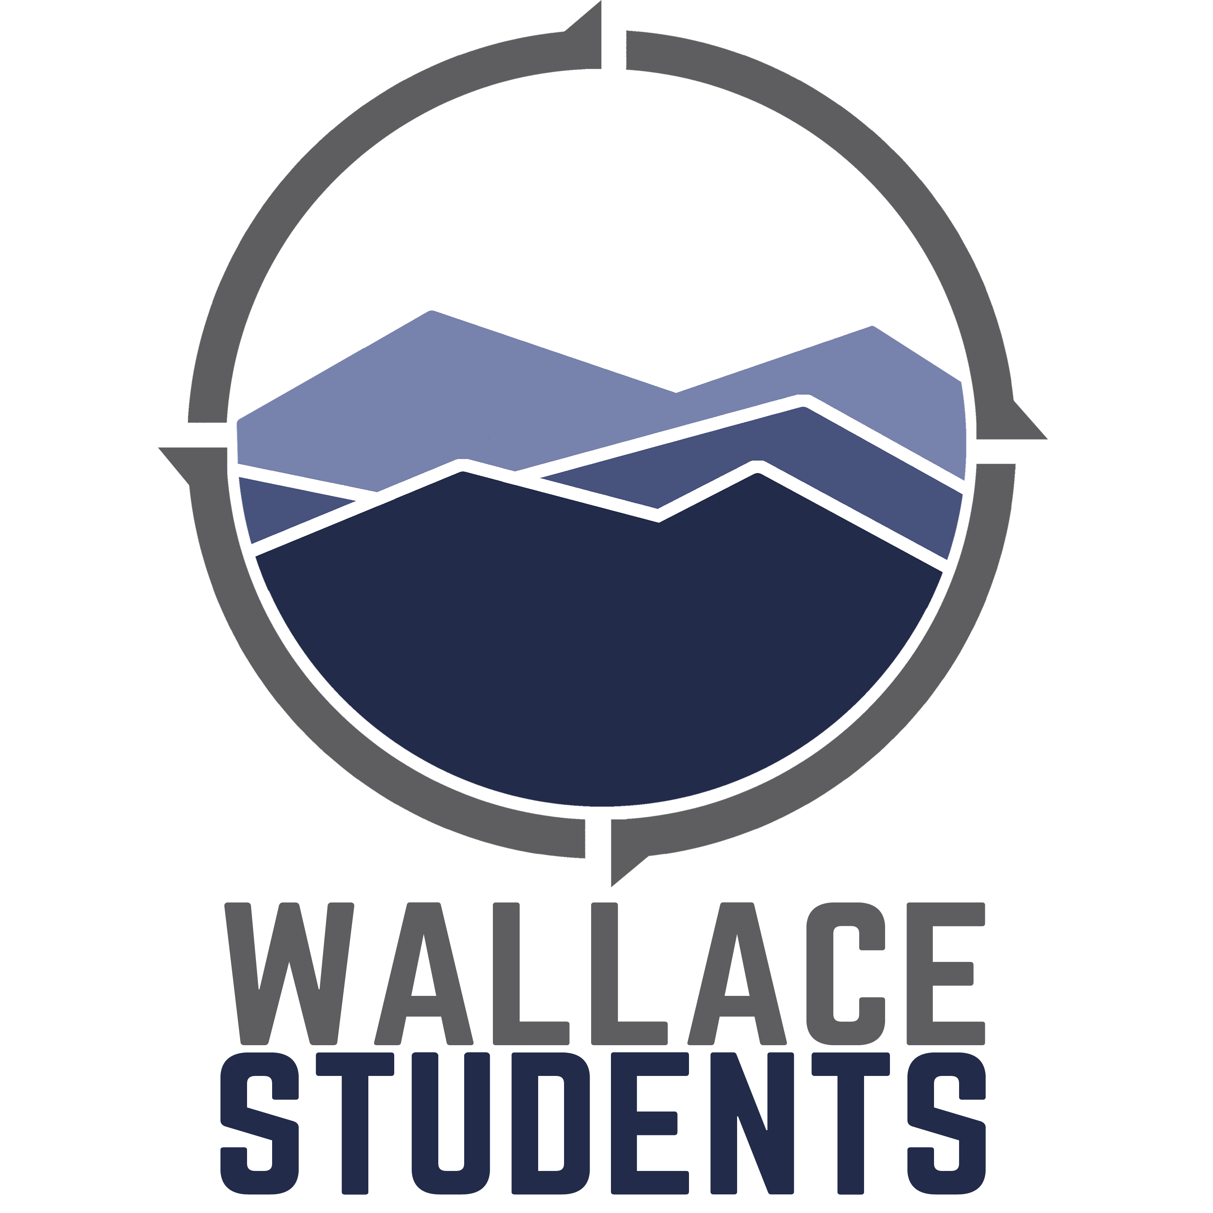
RELEASE OF LIABILITY FORM
Coronavirus (COVID-19)
WKND United 2020

Wallace Students related activities often carry inherent risks which Wallace Memorial Baptist Church endeavors to minimize for everyone as much as possible. Any public activity which requires interaction with individuals during the Coronavirus/COVID-19 pandemic is no exception. Still, all participants must be aware that participation in such activities during this time, potentially increases risk of exposure to COVID-19 and/or the requisite medical quarantine (14 or more days) by government entities, either foreign or US, and medical treatment.
Exposure to COVID-19, and the requisite medical quarantine of such exposure, may require a higher level of financial responsibility for participants in Wallace Students events and activities. Therefore, participants should be prepared to assume any additional costs associated with medical quarantine, medical screenings, and medical treatment, which might become necessary, and which are NOT covered by an insurance provider.
Each participant and/or parent or guardian (if under the age of 18) understands and agrees to assume these increased risks and the associated increased travel and/or medical costs should they become necessary.

I CERTIFY THAT I HAVE READ THIS DOCUMENT, AND I FULLY UNDERSTAND ITS CONTENT. I AM AWARE THAT THIS IS A RELEASE OF LIABILITY AND A CONTRACT AND I SIGN IT OF MY OWN FREE WILL.

Print Participant’s Name |  | Age |  | Signature (if under 18 years old,  Parent or guardian must also sign) |  |  | Date
Print Parent or Guardian Name |  |  |  | Parent or guardian signature (required  If participant is under 18 years old) |  |  | Date

